**This half term, we are going to be learning about the rivers and the water cycle.**

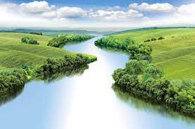

**A river is a body of water which flows down from high ground into the sea. This is because of gravity**

**There are rivers all around the world. They have similarities and differences. All rivers have certain physical features:**

Source: the start of a river  
Bank: the sides of a river  
Bed: the bottom of a river  
Tributary: a small stream which feeds into a river  
Confluence: where two rivers meet  
Waterfall: where a river flows off a vertical drop  
Meander: a bend in a river  
Valley: a long, low area found between mountains  
Mouth: where the river meets the sea

**Rivers play a key roll in the water cycle. The water cycle is how water is moved around the world. It works through evaporation and condensation.**

**Rivers shape the landscape through wearing down the land (erosion) and moving sediment (mud) to different areas.**

**Rivers are important habitats (homes) for many plants and animals.**

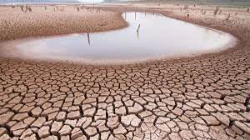

**A drought is when there is not enough rain. Droughts can be dangerous for living things.**

**A flood is when there is too much water for a river to hold and it spills on to land. Floods can be dangerous for living things.**

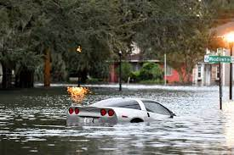

**Rivers affect the lives of the people who live by them. People can also change rivers through pollution and by changing the landscape.**

**Key Vocabulary**

**River**: a body of water which flows down from high ground to the sea.

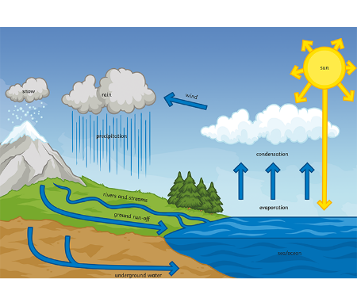**Water cycle:** how water is moved around the world. It works through evaporation and condensation.

**Evaporation:** when heat turns water from a liquid into a gas (water vapour).

**Condensation:** when cooling turns water from a gas into a liquid.

**Habitat:** the home of a living thing.

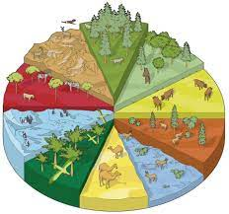

**Drought:** when there is not enough rainfall. Droughts are usually caused by very hot and dry weather.   
  
**Flood**: when there is too much water for a river to hold and it flows on to land. Floods are usually caused by too much rainfall.

**Pollution:** when the environment is damaged by humans leaving waste, rubbish or other harmful things.

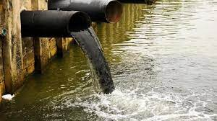

**Fieldwork**: when geographers go out into the world to collect information to base their ideas on.

**Human features:** the parts of a place that have been created by humans.

**Physical features:** the parts of a place that have been formed naturally.